Download BIM One application

<https://bimone.com/en>



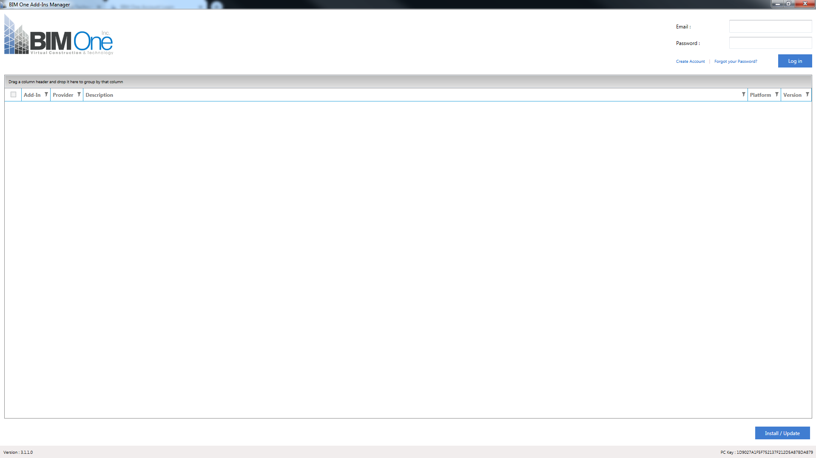

If you don’t already have an account, select “Create Account”



Fill out “New Customer” information then select “Register”

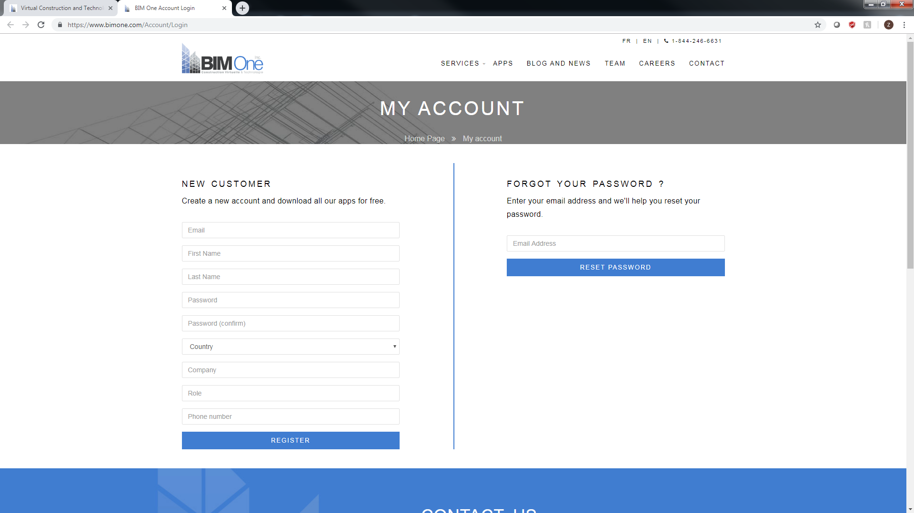

You should have received an email specifying that your account has been activated successfully. If you did not receive this go through the above process once more to create your account.

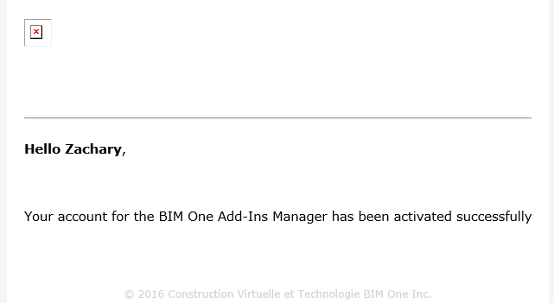

In the BIM One application login to your account. The below information should appear.

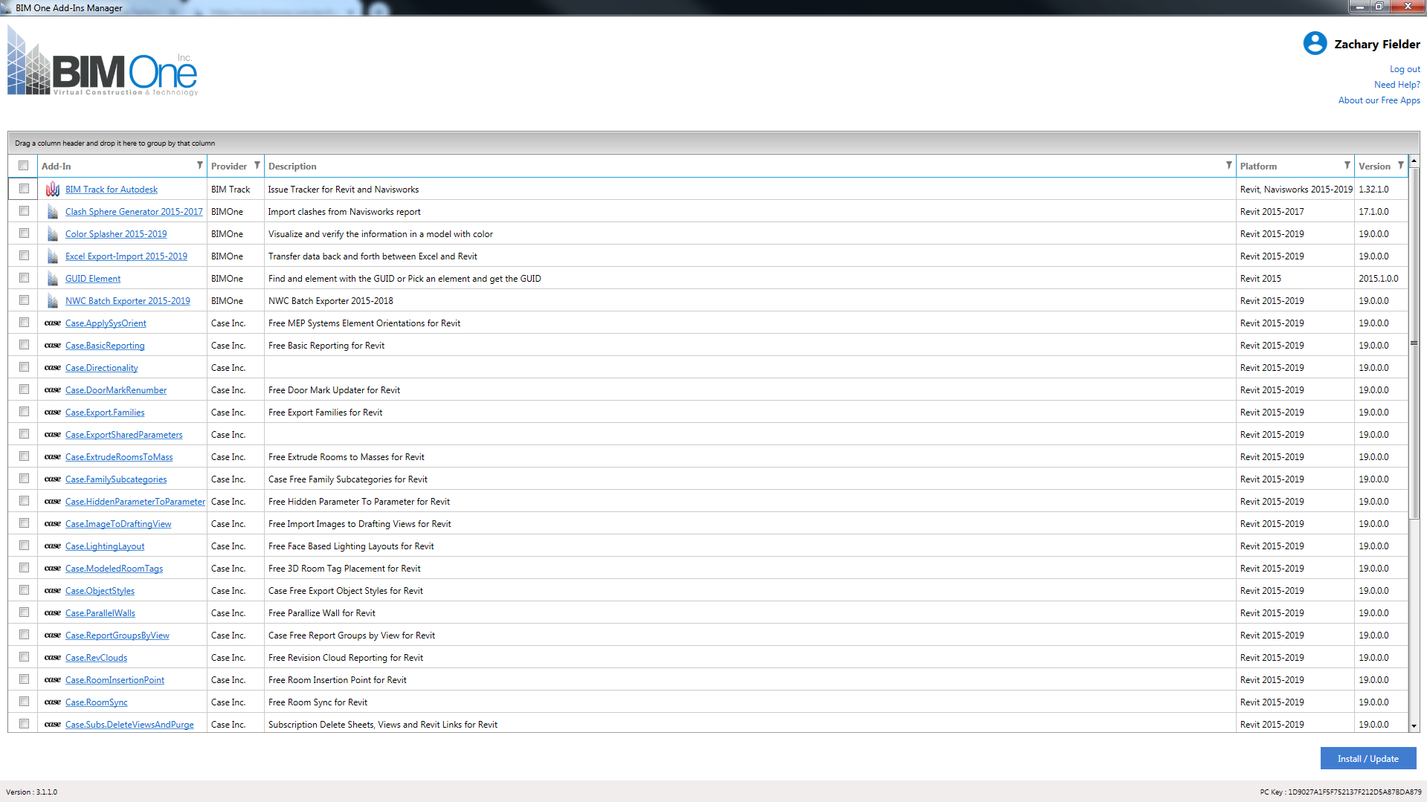

Select the checkbox next to “Excel Export-Import 2015-2019”

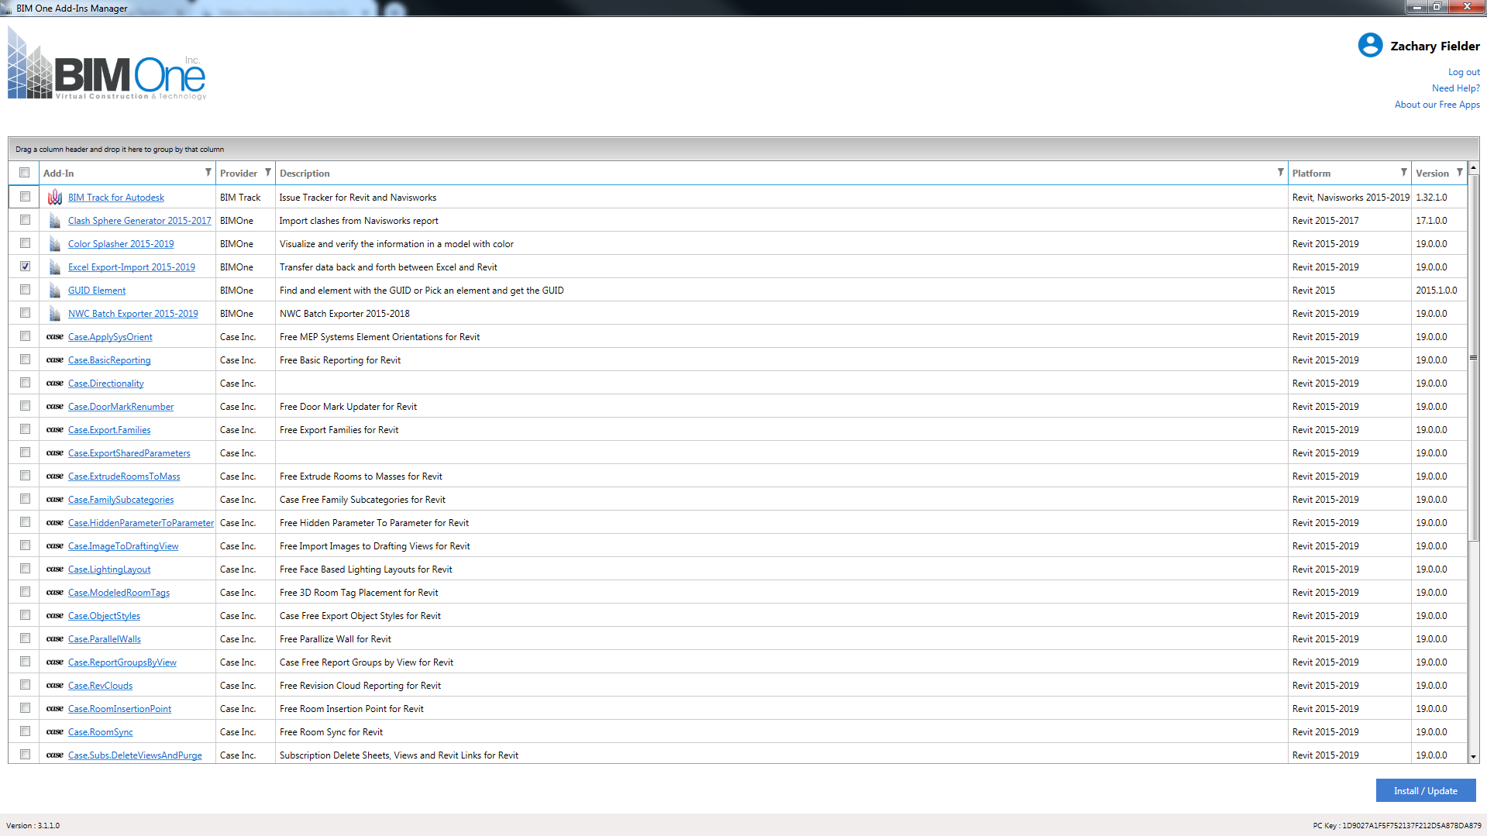

Select “Install/Update”



A dialog box should appear regarding the terms and conditions. Select the check box next to “I agree with BIM One terms and conditions”.

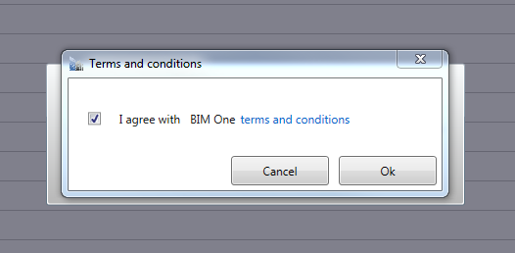

Select “OK”



At this point this application should be included as an add-in in Revit. When opening Revit again you may have a dialog box appear as shown below.

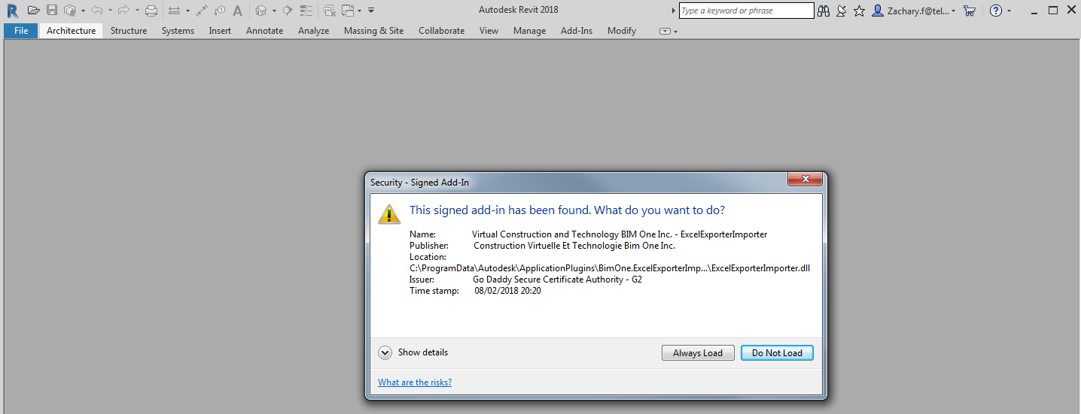

Select “Always load” to always have the option to use this application.



In Revit, there should be an additional tab labeled “BIM One”. Select it.

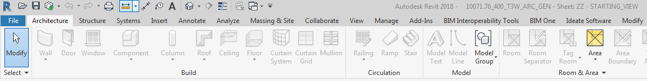

To export a schedule to Excel select “Export/Import Excel”.

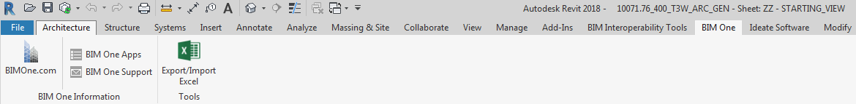

A dialog box should appear with two individual tabs. To export an excel spreadsheet ensure you’re in the “export” tab.

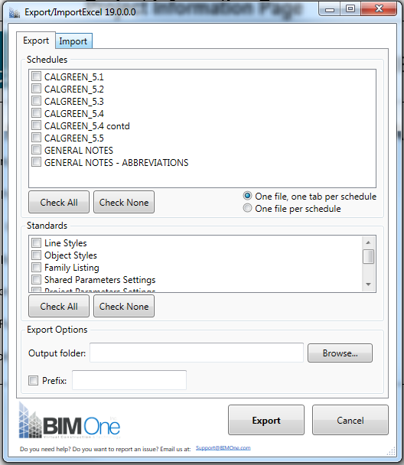

Select the schedule(s) you would like to export in the “Schedules” section.

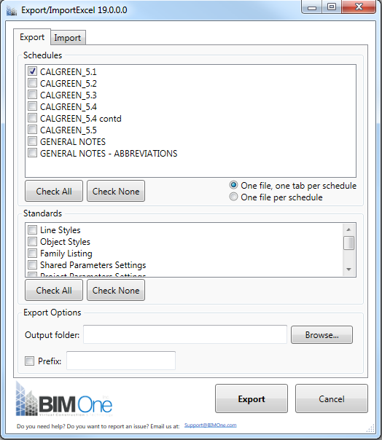

You also have the option to export standards. Select the standards you would like to export in the “Standards” section.

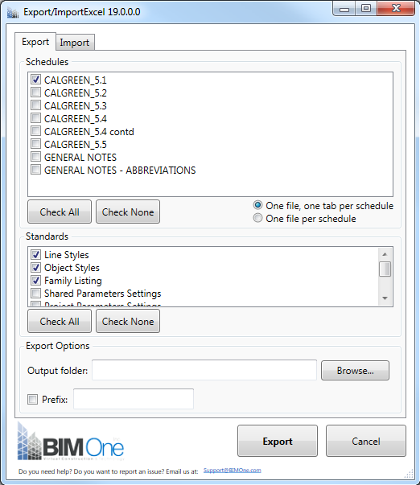

Next, select “Browse” to choose a location where you would like to export the selected schedule(s).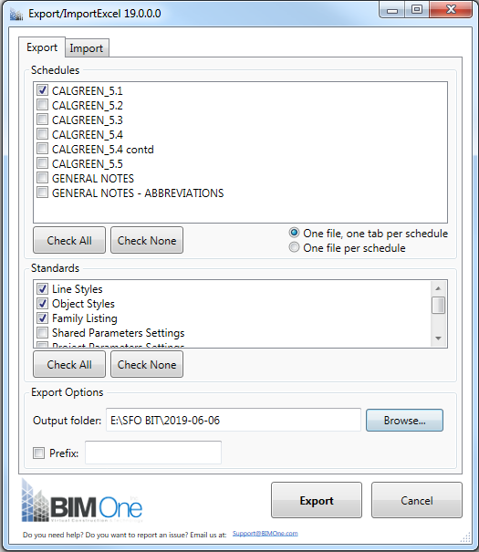

Select “Export”.



Update the schedule(s) as necessary in Excel.

To import the schedule(s) back into your Revit you’re going to follow a similar process as before to get back to the “Export/Import Excel” dialog box. However, instead of remaining under the “Export” tab you’re going to select the “Import” tab.

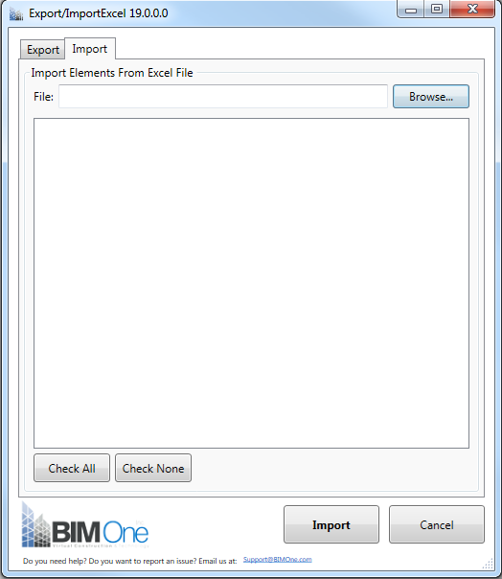

Select “Browse” to choose the excel file(s) that you would like to import as a schedule or standards back into Revit.

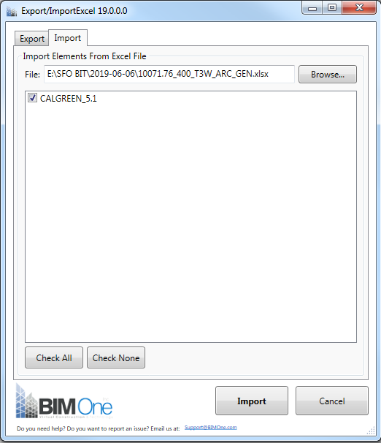

If the schedule you imported is already existing in the Revit model it will be updated per your Excel file. If the name of the Excel file is nonexistent it will be included as a brand-new schedule.